**[Remove Watermark](http://cbs.wondershare.com/go.php?pid=5239&m=db)**

**Wondershare PDFelement**

STARK COUNTY

APPLICATION  
FOR CONSTRUCTION PERMIT

Date

Application is hereby made for a construction permit involving the premises legally described as follows:

Is the above described property located in a floodplain? UYes □ No

Draw below or attach site plan showing proposed structure  
(Include size, distance from property lines, roads, etc.)

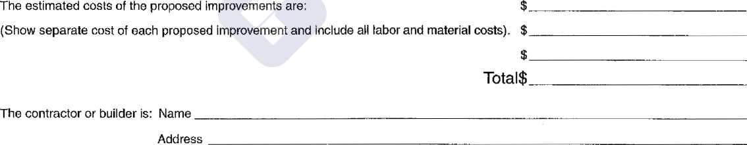

I hereby declare that the information contained herein is correct and agree, in consideration of the issuance of a construction permit, to do or allow to be done only such work as is herein applied for, and that said premises and their existing and proposed building, buildings or structures shall be used or allowed to be used only for such purposes as set forth above or other uses permitted in the district.

Owner

Address

Telephone

Signed by

Address